Predicting Transport, Mixing, and Reaction
in Fractured Porous Media Across Scales
Peter K. Kang
Department of Earth and Environmental Sciences, University of Minnesota, Twin Cities
Abstract: Fluid flow and reactive transport in geologic fractures control many critical natural and engineered processes in the subsurface. For example, 99% of global unfrozen freshwater is stored in groundwater systems, and groundwater flow is often dominated by fracture flows. Also, engineered carbon mineralization is considered a key solution for climate change, and fractures serve as highways for the delivery of CO₂ into mafic and ultramafic rocks, determining the efficiency of carbon mineralization. However, predicting transport processes in fractured porous media is challenging due to the multi-scale heterogeneity inherent to subsurface systems and the strong coupling between processes (i.e., coupled thermo-hydro-mechanical-biological-chemical processes).
In this talk, I will present how my research group uses cutting-edge methods such as high-performance computing, machine learning, and microfluidic experiments to advance our fundamental understanding and predictive capability of coupled processes in fractured porous media. In particular, pore-scale flow effects on transport, mixing, and biogeochemical processes will be highlighted, and a contaminated fractured aquifer site which I have been developing as a teaching and research-integrated site will be introduced.

Brief Bio: Peter K. Kang
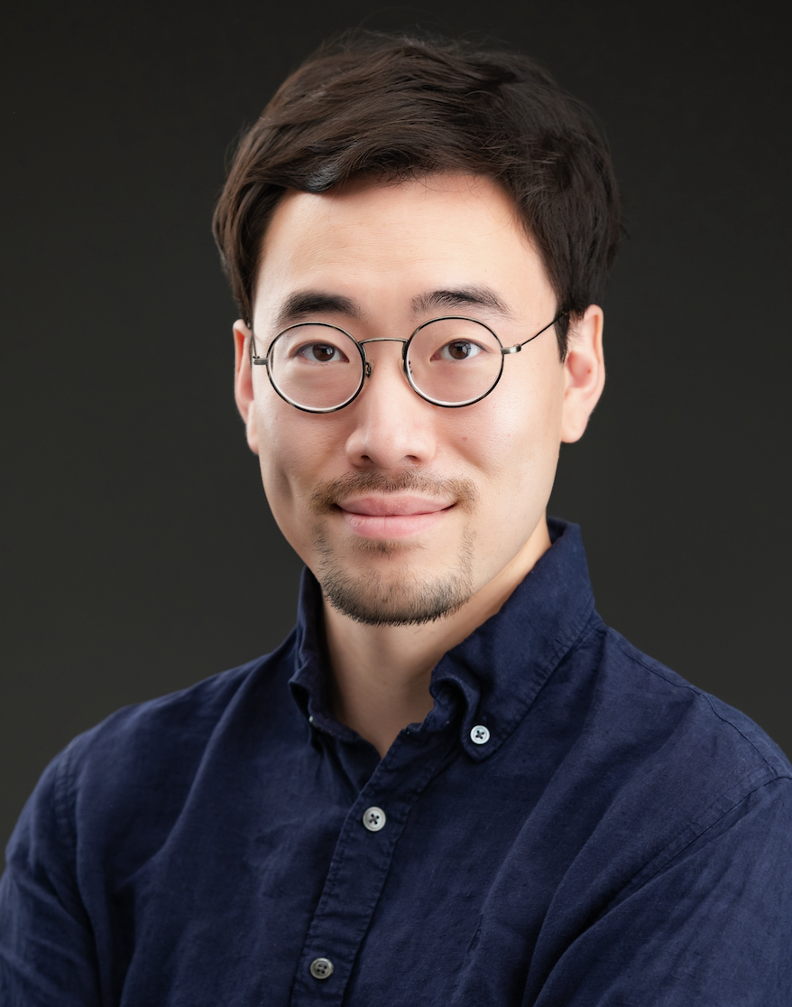

I am a geoscientist whose research focuses on the physics of flow and reactive transport in porous and fractured media. Peter Kang and his group combine a range of methods (lab and field experiments, numerical simulations, and machine learning) to investigate reactive transport in porous media with applications in geologic carbon sequestration, enhanced geothermal systems, and groundwater management and remediation (https://pkkang.com).

I am an Associate Professor and the Gibson Chair of Hydrogeology in the Department of Earth and Environmental Science at the University of Minnesota. I was a researcher at Korea Institute of Science and Technology (KIST) from 2015-2018, and was a postdoctoral associate in the Earth Resources Laboratory (ERL) at MIT before joining KIST. I received my MSc (2010) and PhD (2014) in Civil & Environmental Engineering at MIT, and obtained BSc of Civil, Urban & Geosystem engineering at Seoul National University in South Korea with summa cum laude in 2008.

Major Awards
- McKnight Presidential Fellow Award, University of Minnesota, 2023
- Chin-Fu Tsang Coupled Processes Award, CouFrac 2022
- National Science Foundation (NSF) Early CAREER Award, 2021
- ACS PRF Doctoral New Investigator Award, 2021
- The 3M Company, Non-Tenured Faculty Award, 2019

